Feminine Defaults are Associated with a Reduction in the Gender Participation Gap in MBA Classrooms

Abstract
Record numbers of women have enrolled in MBA programs, yet gender disparities in classroom and career outcomes persist. Why might this be? Historically, business schools have been male-dominated and characterized by masculine defaults. That is, they are contexts in which characteristics associated with the male gender role are regarded as ideal or standard. Our study examines whether there is a gender participation gap in MBA classrooms—a key factor in students’ success. We also investigate whether professors’ behavior relate to the size of the gap. With an observational field study (N = 3159 students across 76 MBA classrooms) of students’ participation behavior and thin-slice impressions of professors, we find that there is a gender participation gap, but the extent to which professors’ behavior convey a relatively feminine default (i.e., characteristics associated with the female gender role as ideal or standard) is associated with a reduction in this gap.
Statement of Relevance
Gender disparities persist in corporate America and business schools. To reduce these disparities, business schools have focused on increasing the gender diversity of the students in their MBA programs. Has increasing gender diversity in terms of who has access to the classroom sufficient to reduce gender disparities in participation within the classroom? Our work investigates whether a gender gap in participation exists at a business school with high gender diversity. We find that, overall, there is a gender participation gap in MBA classrooms. However, we also find a reduction in this gap in classrooms in which professors appear approachable and interpersonally oriented. These findings shed light on possible interventions (e.g., training professors to exhibit interpersonal responsiveness) that leaders can implement in historically male-dominated contexts to create more equitable spaces where both women and men can thrive.

Feminine Defaults are Associated with a Reduction in the Gender Participation Gap in MBA Classrooms
Despite momentous gains towards equality, gender disparities persist in historically male-dominated contexts like corporate America and business schools (Jeong & Harrison, 2017). For example, in the Master of Business Administration (MBA) classroom, women tend to earn lower grades than their male counterparts (e.g., Kanter, 2013; Wallen et al., 2017). Following MBA graduation, women (vs. men) earn lower salaries and are less likely to reach the upper echelons of the corporate hierarchy (e.g., Bertrand et al., 2010). To mitigate gender disparities in the classroom and beyond, many business schools have focused on attracting and recruiting more students who are women (Bryne, 2015; Kantor, 2013). Their efforts have largely succeeded. The top three business schools, for example, have record numbers of women in their student body: University of Chicago Booth (40%), University of Pennsylvania Wharton (47%) and Northwestern University Kellogg (43%; US News and World Report, 2022).
While these efforts to increase gender diversity are undoubtedly an important step, they may not be sufficient to eliminate gender inequality in the classroom. Here, we present a field investigation that examines gender disparities in MBA classroom participation. We focus specifically on the potential gender gap in classroom participation because it is a critical outcome in business school settings in that it both reflects underlying gender disparities and can fuel them. Gender gaps in classroom participation reflect broader gender disparities because they communicate normative information about whose voices matter, are heard, and represented (e.g., Carter et al., 2018). Further, given that classroom participation impacts students’ learning and grades particularly in MBA programs where classes often include case discussions (Schmidt-Wilk, 2010), such gaps can fuel broader gender disparities in outcomes. The current research tracks students’ actual classroom participation behavior and naturalistic thin-slices of professors’ behaviors to document (a) whether there is a gender participation gap in MBA classrooms, overall, and (b) if professors’ behaviors are associated with a reduction in the gender participation gap.
Gender diversity and disparities in MBA classrooms
Research has offered two competing predictions regarding how business schools’ efforts to increase gender diversity might affect the gender participation gap in MBA classrooms. One possibility, in line with business schools’ goals of reducing inequality, is that increased gender diversity in business schools is sufficient to reduce the gender participation gap. Consistent with this possibility, research suggests that increasing women’s representation in higher education settings can reduce gender disparities in students’ experiences and behavior (e.g., Griffith, 2010). By increasing the gender diversity of business schools, women will likely feel a greater sense of belonging and may participate more fully in the academic environment (Kantor, 2013; Lawson et al., 2022; Schmader & Sedikides, 2018).
Another possibility, however, is that increased gender diversity in business schools may be necessary—but not sufficient—to reduce the gender participation gap. Consistent with this, research finds that, despite increased gender diversity, men are more likely than women to speak up and promote themselves in traditionally male-dominated contexts like business or STEM (e.g., Brescoll, 2011; Jarvis et al., 2022; Vial et al., 2022). Gender disparities occur in these settings, in part, because they are characterized by masculine defaults. That is, these are contexts where characteristics associated with the male gender role are regarded as the ideal or standard (Cheryan & Markus, 2020). For example, business schools typically expect students to be analytical and assertive—characteristics associated with the male gender role—rather than receptive and responsive—characteristics associated with the female gender role (Bohlmeyer et al., 1985; Lu et al., 2022; Sinclair, 1995). As a result, MBA students tend to feel like they are being judged by their professor and peers, and exhibit hypercompetitive behaviors (Kelan, 2013; Simpson; 2006). Such expectations and behaviors signal that women—and characteristics associated with the female gender role—are not included. Given that business schools are characterized by masculine defaults (e.g., Kelan, 2013; Sinclair, 1995; Simpson, 2006), men might participate more than women in MBA classrooms, producing a gender participation gap. Accordingly, we propose the following:

Hypothesis 1: There will be a gender participation gap in MBA classrooms, such that men will participate more than women.

Although the larger business school setting is characterized by masculine defaults, professors’ behavior within the classroom is not monolithic. Indeed, professors can convey a relatively feminine default in MBA classrooms when they behave in ways that make them appear approachable and interpersonally oriented (e.g., using a style of speaking that invites questions from students; Anderson & Smith, 2005). Consistent with work demonstrating that subtle signals in a room (e.g., posters) can affect women’s feelings of fit in a STEM setting (Cheryan et al., 2009), professors’ behavior within the classroom may also shape students’ behaviors and experiences beyond the larger default of the business school (e.g., Bright et al., 2012).
Professors whose behavior convey a relatively feminine default are more likely to align with and include the communal orientations that tend to be common among women (Diekman & Steinberg, 2013; Eagly et al., 2000). When professors’ behavior convey that women’s cultural orientations are included, women may be more likely to participate in the classroom. At the same time, conveying a relatively feminine default may also encourage egalitarian and cooperative behaviors (e.g., turn-taking) instead of individualistic and competitive behaviors among all students (e.g., Berdahl et al., 2018; Cheryan & Markus, 2020). As a result, students may not feel like they need to prove themselves or stand out from others (Anderson, 1996). In either case, we expect that the more professors’ behavior convey a relatively feminine default, the smaller the gender participation gap will be and propose the following:

Hypothesis 2: The classroom feminine default as conveyed by the professors’ behavior will be associated with a reduction in the gender participation gap, such that men and women will not differ in their participation.

Current Research
To examine our hypotheses, we coded students’ participation behavior and thin-slice impressions of professors in an observational study of 76 MBA classes (N = 3159 students) at a business school with relatively high gender diversity. Trained research assistants, who were unaware of hypotheses, coded 90-minute MBA classroom video recordings for student and professor gender as well as student participation behavior (i.e., instances of participation). Additionally, a separate set of trained research assistants coded the extent to which professors’ behavior conveyed a feminine default (i.e., appeared approachable and interpersonally oriented). By coding behaviors of both students and professors, we test whether the classroom feminine default as conveyed by the professor is related to the gender participation gap, over and above other classroom features like professor gender and classroom gender diversity.
Method
The videos included in our study were recorded as part of an ongoing initiative of the business school’s administration to better understand and improve the nature of students’ classroom experiences. Professors teaching in the Spring 2016 term were contacted for their consent to video record their class sessions. They were told that a key part of the business school’s administration’s effort to better understand current classroom dynamics was to videotape classes during Spring 2016. The administration ensured that professors understood that the videos would not be used to evaluate classes or professors. Only one professor opted out of having their class recorded. For professors who did not opt out, class sessions were videotaped for one week in the beginning of the Spring 2016 term. The camera was placed inconspicuously at the front of the classroom but could be seen by students. If students asked about purpose of the camera, professors informed them that the purpose was to learn more about their classroom experience.
Every course offered to full-time MBA students in the Spring of 2016 that met the following filter criteria were recorded: (a) Full-time MBA courses only, (b) Courses offered on the main business school campus only, (c) Courses offered in Spring 2016 only, (d) Removed courses not offered the previous year (i.e., new classes), (e) Removed independent study courses, foreign study courses, and courses with no professor, (f) Removed courses that were not taught by full-time faculty (i.e., classes taught by postdoctoral scholars), (g) Removed lab and field work courses (i.e., those where classroom-based recording was not feasible), (h) Removed courses with no determined schedule (i.e., those where it would not be possible to determine a time to film), and (i) Removed any remaining additional courses as recommended by the Dean of MBA programs.
Given the original purpose of the administration to improve classroom quality, Institutional Review Board (IRB) approval was not initially required to collect the class session video recordings. After the video recordings were collected, however, IRB approval was obtained to use the video recordings for our research. The data and code for the study are publicly accessible https://osf.io/syqfd/?view_only=e0c50ee9cfda43f38132a5457989fd79. We describe the materials and measures in the main text and in the Supplemental Materials. There is no preregistration for the study.
Research Setting
The current research was conducted in MBA classrooms at a private Midwestern business school that had approximately 40% women at the time the data was collected. As such, this setting reflects a business school context where women are relatively well-represented (an analysis of the Top 12 full-time U.S. MBA programs documented that, on average, 37% of MBA students were women in 2016, the year these videos were recorded; GMAC, 2016).
Participants
We obtained 82 video recordings of MBA class sessions. Six videos could not be used due to technical errors with the recording. The 76 remaining video recordings included 3159 MBA students and 46 professors across 51 MBA courses. There were 51 class sessions that were 90 minutes (1.5 hours) in length and 19 class sessions that were 180 minutes (3 hours) in length. To ensure that sessions were similar lengths, we split the video recordings of the 19 three-hour classes into two segments at a natural class break. For these 19 classes, we used the coding of the first segment of the class for our analyses and excluded the second segments’ coding from our analyses. We did this instead of analyzing at the class level (i.e., combining the two segments into one class) for two reasons. First, in some classes, the total number of students between the first and second segments differed (i.e., some students left and did not return after the class break). Second, there were instances where students sat in a different seat in the second segment of class than the first, and we were unable to reliably track which seat the student moved to due to video quality. However, all hypothesis tests yielded identical conclusions when we conduct our analyses with the second segments instead of the first segments. See the Supplemental Materials for results.
Video Coding Procedure
We trained nine research assistants, who were unaware of the hypotheses, on a standardized coding scheme to code the classroom video recordings for student and professor gender, student participation, and student confidence. We trained two additional research assistants to code thin-slices of professors’ behavior. To facilitate coding of student’s gender and participation in the classroom video recordings, we created a seating chart (see Fig. 1). A total of approximately 200 hours was spent coding the video recordings. In the first phase, to establish interrater reliability, each of the research assistants coded 2 of the video recordings. All codes displayed acceptable levels of reliability between coders, ρ > 0.82 (e.g., Fleiss, 1981). After reliability was established, in the next phase, research assistants individually coded a random subset of the remaining classroom video recordings. Once all videos were coded, any disagreements were resolved through discussion. We describe the student-level coding and classroom-level coding in greater detail below.
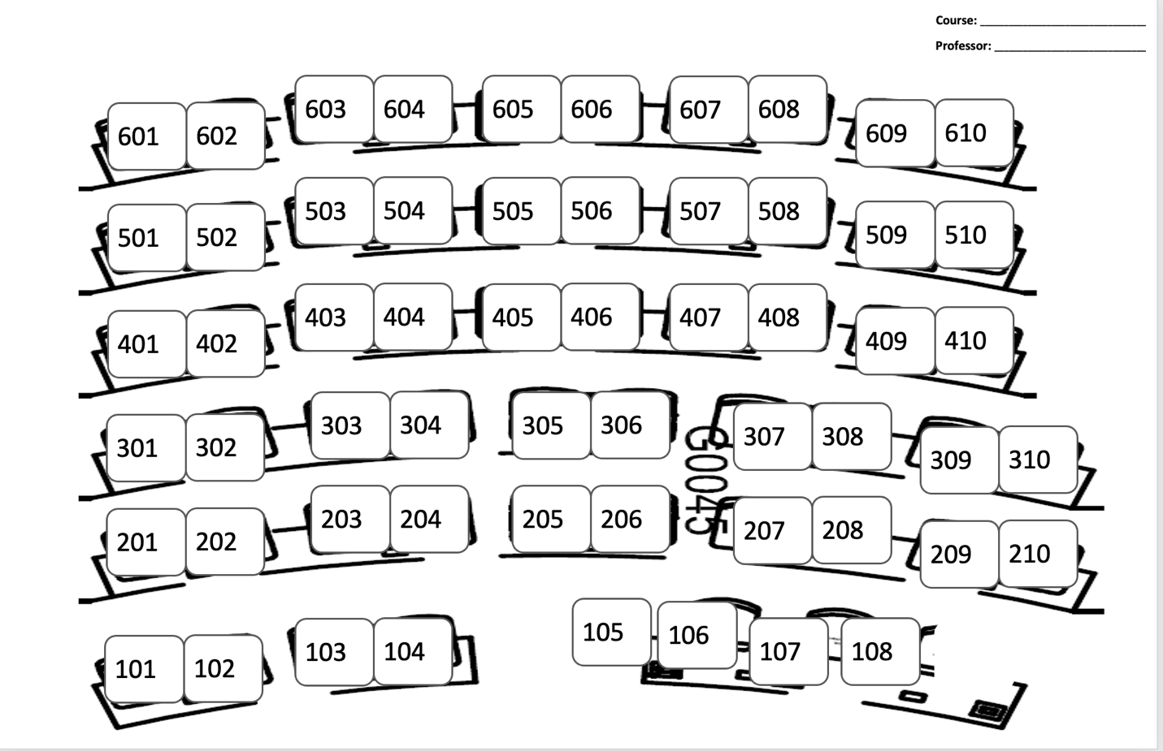
Fig. 1. Example visual map of an MBA classroom layout.

Student Level Video Coding
Student level coding includes students’ perceived gender and participation.
Student Gender. Research assistants coded what they perceived to be the students’ gender. Specifically, we instructed research assistants to use their best judgement to identify students as men or women. Across all class recordings included in our analyses, 1269 students were designated as women (40%), and 1890 were indicated as men (60%), reflecting the gender composition to the general student population enrolled in the full-time MBA program at the university.
Participation. To examine the gender participation gap in the classroom, we used two measures: students’ raw participation and a participation discrepancy score.
Raw participation score. Research assistants coded the number of times each student participated during class (M = 0.91, SD = 1.47, range = 0 -14). We coded participation during entire classroom discussions (i.e., not during small breakout group discussions). There was a total of 2927 instances of student participation across all video recordings. Beyond a raw count of the total number of times each student participated during class, we also had research assistants categorize the type of participation more specifically (e.g., whether the student raised their hand before participating or not). Given that our theorizing focused primarily on instances of participation in general, we report the details of this coding in the Supplemental Materials.
Participation discrepancy score. To account for variation in both classroom size and opportunities for participation in a given classroom (e.g., some classrooms are primarily lecture-based, limiting overall opportunities for participation compared to those that are more discussion-based), we also constructed a participation discrepancy score. This score compares the extent to which students’ actual observed participation deviates from their expected participation if all students in a particular classroom participated equally. The construction of this metric therefore accounts for both differences in classroom size (i.e., number of students in class) and number of participation opportunities (i.e., 72% of class sessions were lecture-based, while 28% of class sessions were relatively more discussion-based).
We computed each students’ participation discrepancy score (M = 0.35, SD = 1.40, range = -0.92 – 13.19) by creating a difference score between the raw participation score (i.e., number of times the student participated) and the expected student participation rate if all students participated equally in a classroom (i.e., dividing the total instances of student participation by the total number of students in a classroom).
For example, in a classroom with 30 students (i.e., total number of students) in which there were 30 total instances of student participation, the expected participation if all students participated equally would be one (i.e., 30/30). If a student participated three times, then that student would receive a participation discrepancy score of two (i.e., three minus one). Given that the student’s participation discrepancy score is greater than zero, this would indicate that the student participated at a higher rate than expected if all students in the class participated equally.
Classroom Level Video Coding
Our classroom level coding included course features, professors’ gender, and the extent to which professors’ behavior conveyed a relatively feminine default.
Course Features. In addition to class format (i.e., whether the course was lecture-based, discussion-based, or a combination), we coded for class activities (77% no class activities, 23% at least one class activity), and length of the class session (M = 88.42 minutes, SD = 12.37 minutes, range = 39-116 minutes). Consistent with previous work (Reinwald & Kunze, 2019), we calculated the classroom gender diversity by dividing the number of women by the total number of students (M = 0.40, SD = 0.14).
Professor Gender. Similar to the student gender coding, research assistants coded what they perceived to be the professors’ gender. Across all video recordings, five professors were identified as women (11%) and 41 professors were identified as men (89%). This is similar to the overall gender composition of the business school’s faculty during the same time period (i.e., 2015-2017; 18-24% women; Anonymous, 2017).
Classroom Feminine Default (Conveyed by Professor Behavior). We used the thin-slicing approach to capture the extent to which the professor’s behavior convey a feminine default (e.g., appearing approachable and interpersonally oriented). Specifically, research assistants coded the first 30-seconds of the professor lecturing in the video recording. The thin-slicing approach has been shown to reliably detect perceptions of cultural dynamics (Ambady & Rosenthal, 1992). Furthermore, previous research finds that when people observe a brief pattern of behavior, they can reach similar and accurate judgements about a variety of characteristics of a target (Ambady & Rosenthal, 1992; Kraus & Keltner, 2009).
To capture the classroom feminine default, we created a composite of four thin-slice ratings of the professor’s warmth (M = 3.56, SD = 0.80), responsiveness (M = 3.45, SD = 0.74), comfort (M = 3.80, SD = 0.85), and lack of formality (M = 1.93, SD = 0.91). We chose these four dimensions based on existing literature on gender defaults and fundamental dimensions of person perception (e.g., Cheryan & Markus, 2020; Fiske, 2018). Additionally, these dimensions were both meaningful (e.g., warmth; cf. Fiske, 2018) and differentiable (i.e., captured distinguishable manifestations of behavior that could be reliably identified by research assistants; Yoder et al., 2010). Furthermore, an exploratory factor analysis resulted in all 4 items loading onto a single factor that explained 77.81% of the variance (all loadings ≥ 0.80), providing additional evidence that the four dimensions reflected a single underlying construct of classroom feminine default.
To create our composite, we averaged each thin-slice rating across two research assistants. The overall interrater reliability across all the four dimensions was high (r_{average} = 0.68: warmth: r = 0.75, responsiveness: r = 0.51, comfort: r = 0.84, lack of formality: r = 0.63). Higher values on the composite indicate that the professor’s behavior conveyed a relatively more feminine default (α = 0.87, M = 3.19, SD = 0.70). We describe the four ratings in more detail below and provide the full coding instructions in the Supplemental Materials.
Professor’s Warmth. Research assistants coded the extent to which the professor appeared warm in the video clip using a scale of 1 (cold) to 5 (most warm). A high score on this measure indicated that the professor made good eye contact with their students, had a style of speaking that invited questions from students, exhibited high energy movement or voice inflection, used humor, and/or used disarming language (Fiske, 2018).
Professor’s Responsiveness. Research assistants indicated the extent to which the professor created a pleasant and engaging classroom in the video clip using a scale of 1 (least agreeable) to 5 (most agreeable). A high responsiveness score indicated that the professor created an engaging class, conveyed ideas clearly to students, and exhibited dynamic movements throughout class (e.g., walking around the classroom; Hoyle et al., 1989).
Professor’s Comfort. Research assistants indicated the extent to which the professor appeared comfortable and at ease when lecturing and speaking to students in the video clip using a scale of 1 (least comfortable) to 5 (most comfortable). Following prior research, a high comfort score indicated that the professor appeared comfortable and at ease when lecturing and speaking to students (e.g., Hoyle et al., 1989).
Professor’s Lack of Formality. Research assistants indicated the extent to which the professor appeared formal in the video clip using a scale of 1 (not at all formal) to 5 (extremely formal). Professors were rated as highly formal if they did not use humor, did not chat lightly with students, and/or did not have a relaxed posture (M = 4.07, SD = 0.91; e.g., Hughes & Avey, 2009). We reversed-score these ratings to indicate the extent to which the professor lacked formality.
Results
Analysis Plan
For all measures, we include a standard set of covariates: professor’s gender (0 = woman, 1 = man) and classroom gender diversity (mean-centered). We controlled for professor’s gender because it is associated with student participation (Tatum et al., 2013). We controlled for the classroom gender diversity (i.e., proportion of women in the classroom) because we reasoned that women would participate more frequently, regardless of the default conveyed, if there was greater classroom gender diversity (e.g., women participate more when there is a larger proportion of women in the setting; Murphy et al., 2007). When covariates are not included, the significance and direction of our results remain unchanged (see Table 1).
As indicated above, we used two participation measures to test our hypotheses: the raw participation score and the participation discrepancy score. For the raw participation score, the intraclass correlation (ICC; measure of the dependence of observations within a group) indicated that there was dependence of observations or clustering within sessions (Danyluck & Page-Gould, 2018; Gordon, 2018), 𝜌 = 0.16. Therefore, we conducted a 2-level mixed-effects linear regression analysis in which students were nested within class sessions using student gender (effect-coded: -1 = woman, 1 = man) as a predictor. We also conducted 2-level mixed-effects moderation analyses using classroom feminine default (mean-centered).
For our participation discrepancy score measure which includes number of students and total participation in the class session, there was low dependence of observations within sessions, 𝜌 < 0.10. Therefore, we did not conduct multi-level model analyses (Gordon, 2018) and instead conducted an Analysis of Covariance (ANCOVA) using student gender (dummy-coded: 0 = woman, 1 = man) as a predictor. For our moderation analysis on participation discrepancy score, we conducted moderated regression analysis. We entered our standard set of covariates on Step 1. Then, we entered student gender (0 = woman, 1 = man) and classroom feminine default (mean-centered) on Step 2, and their interaction on Step 3.
Is There a Gender Participation Gap in MBA Classrooms on Average?
In support of Hypothesis 1, when using raw participation as our outcome, there was a gender gap in the number of participation instances such that men participated more than women, b = .130, t (3072) = 5.07, p < .001, 95% CI [0.08, 0.18] (see Table 1). Given that men made up 60% of the students across all classrooms, we would have expected men to participate about one and a half times as much as women do. Instead, we find that across all classrooms, men participated twice as much as did women. Indeed, a chi-square analysis comparing students’ expected participation based on their representation compared to their actual participation show that men (vs. women) disproportionately participated, 𝝌²(1, N = 3155) = 32.52, p < .001, φ_{c} = .114.
We found consistent effects with the participation discrepancy score; there was a gender gap in participation across classrooms such that men (vs. women) participated more than expected if all students participated equally, b = .260, t (3151) = 5.13, p < .001, 95% CI [0.16, 0.36] (see Table 1).

Table 1.
Results of Analyses Examining Main Effects of Student Gender on Participation

 | Raw Participation Score |  | Participation Discrepancy Score
 | Model 1 | Model 2 | Model 1 | Model 2
Student Gender  (1 = man) | .134***  [0.08, 0.18] | .130***  [0.08, 0.18] | .128***  [0.08, 0.18] | .140***  [0.09, 0.19]
Constant | .982 | .130 | -.029 | -.025
Observations | 3159 | 3159 | 3159 | 3159
R-Squared | .009 | .014 | .003 | .003
Control Variables | No | Yes | No | Yes
Note. Model 1 reflects main effects with no control variables, Model 2 includes the standard set of covariates. Brackets reflect 95% CIs; *** p < 0.001.

Are Feminine Defaults Associated with a Reduction in the Gender Participation Gap?
Next, we examined whether feminine classroom defaults are associated with a reduction in the gender participation gap in MBA classrooms (Hypothesis 2) by examining both raw participation score and participation discrepancy score.
First, using raw participation as our outcome variable, we obtained a significant main effect of student gender such that men participated more than women, b = .140, t (2903) = 5.27, p < .001, 95% CI [0.09, 0.19]. There was also a significant main effect of classroom feminine default such that higher levels of classroom feminine default were associated with less participation, b = -.246, t (67) = -2.41, p = .019, 95% CI [-0.45, -0.04]. Importantly and consistent with Hypothesis 2, these main effects were qualified by a significant two-way student gender × classroom feminine default interaction, b = -.110, t (2949) = -2.92, p = .004, 95% CI [-0.18, -0.04] (see Fig. 2).
We next obtained the simple effects of classroom feminine default for the interaction. When professors’ behavior conveyed a relatively less feminine default (i.e., -1 SD below the mean of our classroom feminine default measure), there was a significant gender participation gap such that men participated more than women, b = .217, t (2930) = 5.64, p < .001, 95% CI [0.14, 0.29]. However, consistent with Hypothesis 2, when professors’ behavior conveyed a relatively more feminine default (i.e., +1 SD above the mean of our classroom feminine default measure), there was no gender participation gap, b = .062, t (2927) = 1.71, p = .087, 95% CI [-0.01, 0.13]. We also obtained the simple effects of student gender for the interaction. Among men, the association between classroom feminine default and participation was negative and significant, b = -.356, t (77) = -3.33, p = .001, 95% CI [-0.57, -0.14]. Among women, there was no significant association between classroom feminine default and participation, b = -.136, t (87) = -1.23, p = .221, 95% CI [-0.36, 0.08].
Next, using the participation discrepancy score as our outcome variable, we obtained a significant main effect of student gender such that men participated more than expected (and women participated less than expected) if all students participated equally, b = .136, t (2974) = 5.17, p < .001, 95% CI [0.08, 0.19]. There was no significant main effect of classroom feminine default, b = -.001, t (2974) = -0.03, p = .979, 95% CI [-0.07, 0.07]. However, consistent with Hypothesis 2 and the results when using raw participation score, there was a significant two-way student gender × classroom feminine default interaction, b = -.104, t (2973) = -2.88, p = .004, 95% CI [-0.18, -0.03] (see Fig. 3).
We next examined the simple effects of classroom feminine default. When professors’ behavior conveyed a relatively less feminine default (-1 SD below the mean of our classroom feminine default measure), there was a significant gender participation gap whereby men had higher participation discrepancy scores than women (i.e., men participated more than what would be expected if all students participated equally), b = .426, t (2973) = 5.67, p < .001, 95% CI [0.28, 0.57]. However, consistent with Hypothesis 2, when professors’ behavior conveyed a relatively more feminine default (+1 SD above the mean of our classroom feminine default measure), there was no significant gender participation gap, b = .133, t (2973) = 1.86, p = .062, 95% CI [-0.01, 0.27]. We next obtained the simple effects by student gender. Among men, though in the same direction as the raw participation score measure, the classroom feminine default was not statistically significantly associated with participation discrepancy scores, b = -.092, t (2973) = -1.92, p = .055, 95% CI [-0.19, 0.00]. Among women, the classroom feminine default was not significantly associated with participation discrepancy scores, b = .012, t (2973) = 0.32, p = .747, 95% CI [-0.06, 0.08].

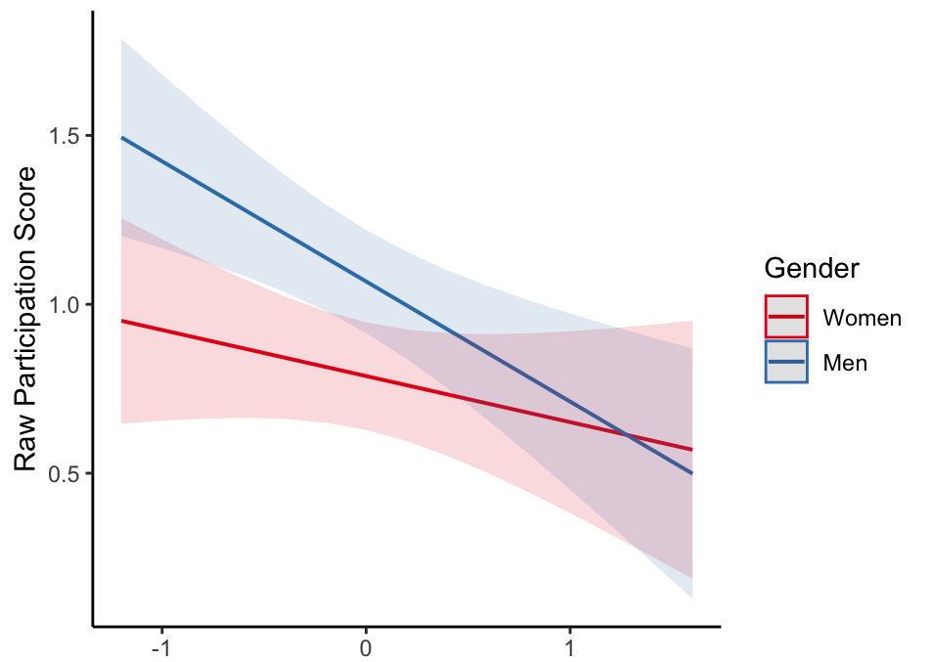
Less Feminine
(-1 SD)
More Feminine
(+1 SD)
Classroom Feminine Default

Fig. 2. The effect of student gender on the raw participation score by classroom feminine default. Graphed at ±1 SD from classroom feminine default mean. The raw participation score indicates the number of participation instances.

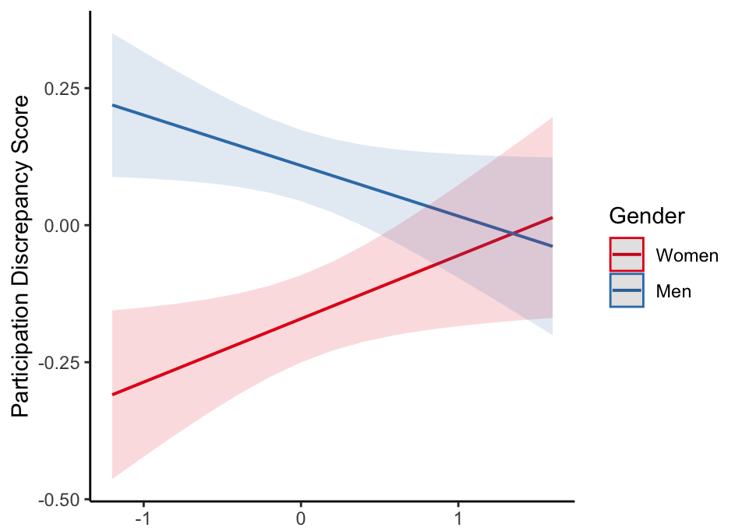
Less Feminine
(-1 SD)
More Feminine
(+1 SD)
Classroom Feminine Default

Fig. 3. The effect of student gender on the participation discrepancy score by classroom feminine default. Graphed at ±1 SD from classroom feminine default mean. The participation discrepancy score indicates the difference score between the students’ raw participation score and the expected participation if all students in the class participated equally.

General Discussion
As a result of significant efforts to increase gender diversity, many business schools are fast approaching gender parity in representation. However, increased gender diversity in access may not be sufficient to eliminate gender inequality in outcomes in MBA programs. In an observational field study capturing students’ participation and thin-slice impressions of professors, we find evidence of a gender participation gap—even in a business school with relatively high gender diversity. Importantly, we find that this gap is not inevitable. Instead, in classrooms in which professors’ behavior conveys a relatively feminine default (i.e., appearing approachable and interpersonally oriented) there is no gender gap in participation.
Our work is the first to directly examine the relationship between professors’ behavior and students’ participation in MBA classrooms and makes important theoretical and practical contributions. Our results suggest that the gender participation gap may persist in historically male-dominated contexts when intervention efforts primarily focus on recruiting gender-balanced cohorts. Efforts to promote gender equality in traditionally masculine settings likely also require tempering the predominant masculine default by actively incorporating a feminine default. For example, professors can be trained to use language that clearly conveys warmth and interpersonal responsiveness when lecturing or communicating with students.
Indeed, our findings suggest that professors play a pivotal role in creating classroom defaults, and that their behavior relates to the size of the gender participation gap. While experimental work has shown that a room’s physical objects can influence self-reported interest in STEM (Cheryan et al., 2009), our results show that subtle cues (e.g., warmth) conveyed by professors’ behavior relates to the gender distribution of participation behavior in MBA classrooms. This indicates that interventions that focus on targeting students as a way to reduce gender disparities in participation may therefore be incomplete. Instead, it may also be necessary to incorporate professors into intervention efforts because their behavior in the classroom can facilitate equitable and egalitarian participation behavior.
Limitations and Future Directions
While our work is the first to document how professors’ behavior is associated with gender disparities in MBA classroom participation, it is not without limitations and has promising directions for future research. One limitation of the present study is that it investigates classroom participation at a single business school that has achieved relatively high levels of gender diversity. Although our analyses account for varying levels of gender diversity at the classroom level, the overall gender diversity at the business school we sampled from may impact our findings. For instance, it is possible that the observed relationship between the gender participation gap and professors’ behavior is weaker in business schools that lack a critical mass of women in their overall student population. Future work should examine whether and how gender diversity at an institutional level interacts with classroom defaults to affect participation.
Second, given the observational nature of our study utilizing classroom recordings, the current study is limited in at least two ways. First, we examined one key component of culture that can convey the classroom default: professors’ behavior. However, defaults can be reflected and promoted through other components of culture (e.g., institutional policies, individual students’ ideas and beliefs; Cheryan & Markus, 2020). Second, we could only use observable indicators (e.g., perceptions of student gender), rather than subjective or self-reported indicators (e.g., students’ self-identified gender). Lacking access to subjective measures may be why a large proportion of variance remains unexplained in our model. Future research is needed to investigate both the effects of different components of culture and subjective measures (e.g., students’ self-identified gender) on gender disparities in classroom participation.
Finally, we find initial evidence suggesting that the classroom feminine default is associated with a reduction in the gender participation gap because of changes in men’s—but not women’s— behavior. This finding is consistent with work demonstrating that gender disparities in speaking time in another context—academic conferences—arise because of men taking up too much space (Jarvis et al., 2022). However, it is inconsistent with research demonstrating that cues of inclusion more strongly affect marginalized groups than dominant groups (e.g., Schmader & Sedikides, 2018). Though the observational nature of our data does not allow us to reconcile these disparate findings, future work should examine when strategies for reducing inequality change the behavior of dominant versus marginalized groups.
Conclusion
Despite record enrollment of women in MBA programs, gender disparities persist in corporate America and business schools. Although increased representation is undoubtedly necessary for reducing disparities, our work suggests that it may not be sufficient. Even in a business school with high gender diversity, we find evidence of a gender participation gap. However, we also document one possible way to reduce this gap: by incorporating a feminine default into MBA classroom cultures. Our findings suggest that local classroom cultures can play a pivotal role in shifting historically male-dominated contexts to become more equitable.

References
Ambady, N., & Rosenthal, R. (1992). Thin slices of expressive behavior as predictors of interpersonal consequences: A meta-analysis. Psychological Bulletin, 111(2), 256. https://doi.org/10.1037/0033-2909.111.2.256
Anderson, M. S. (1996). Collaboration, the doctoral experience, and the departmental environment. The Review of Higher Education, 19(3), 305-326. https://doi.org/10.1353/rhe.1996.0023
Anderson, K. J. & Smith, G. (2005). Students’ preconceptions of professors: Benefits and barriers according to ethnicity and gender. Hispanic Journal of Behavioral Sciences, 27(2), 184-201. https://doi.org/10.1177%2F0739986304273707
Berdahl, J. L., Cooper, M., Glick, P., Livingston, R. W., & Williams, J. C. (2018). Work as a masculinity contest. Journal of Social Issues, 74(3), 422-448. https://doi.org/10.1111/josi.12289
Bertrand, M., Goldin, C., & Katz, L. F. (2010). Dynamics of the gender gap for young professionals in the financial and corporate sectors. American Economic Journal: Applied Economics, 2(3), 228-55. https://doi.org/10.1257/app.2.3.228
Bohlmeyer, E. M., Burke, J. P., & Helmstadter, G. C. (1985). Differences between education and business students in cooperative and competitive attitudes, emotional empathy, and self-esteem. Psychological Reports, 56(1), 247-253. https://doi.org/10.2466%2Fpr0.1985.56.1.247
Brescoll, V. L. (2011). Who takes the floor and why: Gender, power, and volubility in organizations. Administrative Science Quarterly, 56(4), 622-641. https://doi.org/10.1177%2F0001839212439994
Bright, D. S., Turesky, E. F., Putzel, R., & Stang, T. (2012). Professor as facilitator: Shaping an emerging, living system of shared leadership in the classroom. Journal of Leadership Education, 11(1), 157-176. https://doi.org/10.12806/V11/I1/RF9
Bryne, J. A. (2015). Schools succeed in attracting more women. Poets and Quants. Retrieved from https://poetsandquants.com/2015/09/22/schools-succeeding-in-attracting-more-women/
Borkenau, P., & Liebler, A. (1992). Trait inferences: Sources of validity at zero acquaintance. Journal of Personality and Social Psychology, 62(4), 645. https://psycnet.apa.org/doi/10.1037/0022-3514.62.4.645
Carter, A. J., Croft, A., Lukas, D., & Sandstrom, G. M. (2018). Women’s visibility in academic seminars: Women ask fewer questions than men. PloS one, 13(9), e0202743. https://doi.org/10.1371/journal.pone.0212146
Cheryan, S., & Markus, H. R. (2020). Masculine defaults: Identifying and mitigating hidden cultural biases. Psychological Review, 127(6), 1022. https://doi.org/10.1037/rev0000209
Cheryan, S., Plaut, V. C., Davies, P. G., & Steele, C. M. (2009). Ambient belonging: how stereotypical cues impact gender participation in computer science. Journal of Personality and Social Psychology, 97(6), 1045-1060. https://doi.org/10.1037/a0016239
Danyluck, C., & Page-Gould, E. (2018). Intergroup dissimilarity predicts physiological synchrony and affiliation in intergroup interaction. Journal of Experimental Social Psychology, 74, 111-120. https://doi.org/10.1016/j.jesp.2017.08.001
Diekman, A. B., & Steinberg, M. (2013). Navigating social roles in pursuit of important goals: A communal goal congruity account of STEM pursuits. Social and Personality Psychology Compass, 7(7), 487-501. https://doi.org/10.1111/spc3.12042
Eagly, A. H., Wood, W., & Diekman, A. B. (2000). Social role theory of sex differences and similarities: A current appraisal. In T. Eckes & H. M. Trautner (Eds.), The Developmental Social Psychology of Gender (pp. 123–174). Lawrence Erlbaum Associates Publishers.
Fiske, S. T. (2018). Stereotype content: Warmth and competence endure. Current Directions in Psychological Science, 27(2), 67-73. https://doi.org/10.1177%2F0963721417738825
Fleiss, J. L. (1981). Balanced incomplete block designs for inter-rater reliability studies. Applied Psychological Measurement, 5, 105–112. https://doi.org/10.1177%2F014662168100500115
Gordon, A. M. (2018). A practical guide to multilevel modeling [PowerPoint slides]. University of California, San Francisco. https://spsp.org/sites/default/files/SPSP_Webinar_Fall2018_final.pdf
Graduate Management Admission Council. (2016, October 6). Where are Women in Graduate Business School? https://www.gmac.com/market-intelligence-and-research/research-insights/application-trends/where-are-women-in-graduate-business-school
Griffith, A. L. (2010). Persistence of women and minorities in STEM field majors: Is it the school that matters?. Economics of Education Review, 29(6), 911-922. https://doi.org/10.1016/j.econedurev.2010.06.010
Hoyle, R. H., Pinkley, R. L., & Insko, C. A. (1989). Perceptions of social behavior: Evidence of differing expectations for interpersonal and intergroup interaction. Personality and Social Psychology Bulletin, 15(3), 365-376. https://doi.org/10.1177%2F0146167289153007
Hughes, L.W., & Avey, J. B. (2009). Transforming with levity: Humor, leadership, and follower attitudes. Leadership & Organization Development Journal, 30(6), 540-562. https://doi.org/10.1108/01437730910981926
Jarvis, S. N., Ebersole, C. R., Nguyen, C., Zhu, L., & Kray, L. (2022). Stepping up to the mic: Gender gaps in participation in live question-and-answer sessions at academic conferences. https://doi.org/10.31234/osf.io/26n9p
Jeong, S. H., & Harrison, D. A. (2017). Glass breaking, strategy making, and value creating: Meta-analytic outcomes of women as CEOs and TMT members. Academy of Management Journal, 60(4), 1219-1252. https://doi.org/10.5465/amj.2014.0716
Kantor, J. (2013). Harvard business school case study: Gender equity. New York Times. Retrieved from https://www.nytimes.com/2013/09/08/education/harvard-case-study-gender-equity.html.
Kelan, E. K. (2013). The becoming of business bodies: Gender, appearance, and leadership development. Management Learning, 44(1), 45-61. https://doi.org/10.1177%2F1350507612469009
Konrad, A. M., Kramer, V., & Erkut, S. (2008). The impact of three or more women on corporate boards. Organizational Dynamics, 37(2), 145-164. https://doi.org/10.1016/j.orgdyn.2008.02.005
Kraus, M. W., & Keltner, D. (2009). Signs of socioeconomic status: A thin-slicing approach. Psychological Science, 20(1), 99-106. https://doi.org/10.1111/j.1467-9280.2008.02251.x
Lawson, M. A., Martin, A. E., Huda, I., & Matz, S. C. (2022). Hiring women into senior leadership positions is associated with a reduction in gender stereotypes in organizational language. Proceedings of the National Academy of Sciences, 119(9), e2026443119.
Lu, J. G., Nisbett, R. E., & Morris, M. W. (2022). The surprising underperformance of East Asians in US law and business schools: The liability of low assertiveness and the ameliorative potential of online classrooms. Proceedings of the National Academy of Sciences, 119(13), e2118244119.
Murphy, M. C., Steele, C. M., & Gross, J. J. (2007). Signaling threat: How situational cues affect women in math, science, and engineering settings. Psychological Science, 18(10), 879-885. https://doi.org/10.1111/j.1467-9280.2007.01995.x
Reinwald, M. & Kunze, F. (2020). Being different, being absent? A dynamic perspective on demographic dissimilarity and absenteeism in blue-collar teams. Academy of Management Journal, 63(3), 660-684. https://doi.org/10.5465/amj.2018.0290
Schmader, T., & Sedikides, C. (2018). State authenticity as fit to environment: The implications of social identity for fit, authenticity, and self-segregation. Personality and Social Psychology Review, 22(3), 228-259. https://doi.org/10.1177%2F1088868317734080
Schmidt-Wilk, J. (2010). Managing the dynamics of the diversity classroom. Journal of Management Education, 34(6), 791-792. https://doi.org/10.1177%2F1052562910386748
Sinclair, A. (1995). The chameleon of accountability: Forms and discourses. Accounting, Organizations and Society, 20(3), 219-237. https://doi.org/10.1016/0361-3682(93)E0003-Y
Simpson, R. (2006). Masculinity and Management Education: Feminizing the MBA. Academy of Management Learning & Education, 5(2), 182–193.
Tatum, H. E., Schwartz, B. M., Schimmoeller, P. A., & Perry, N. (2013). Classroom participation and student-faculty interactions: Does gender matter?. The Journal of Higher Education, 84(6), 745-768. https://doi.org/10.1080/00221546.2013.11777309
Vial, A. C., Muradoglu, M., Newman, G. E., & Cimpian, A. (2022). An emphasis on brilliance fosters masculinity-contest cultures. Psychological Science, 33(4), 595-612. https://doi.org/10.1177%2F09567976211044133
Wallen, A. S., Morris, M. W., Devine, B. A., & Lu, J. G. (2017). Understanding the MBA gender gap: Women respond to gender norms by reducing public assertiveness but not private effort. Personality and Social Psychology Bulletin, 43(8), 1150-1170. https://doi.org/10.1177%2F0146167217708574
Yoder, P. J., Lloyd, B.P., & Symons, F. J. (2010). Observational measurement of behavior. Springer Publishing Company.

Gender roles are cultural norms and expectations that dictate the characteristics and behaviors that are seen as appropriate or typical for men and women (e.g., Eagly et al., 2000).
We also coded students’ confidence when raising their hand and when speaking. There were no significant gender differences on either measure. We report these results in the Supplemental Materials.
We coded the course syllabi for other classroom-level features that could moderate our effects (e.g., cold calling policies). None of the course features significantly moderated our effects. See the Supplemental Materials for description and analyses.
As robustness checks, we included two additional covariates in our analyses: whether the course was quantitative and years since the professor’s bachelor’s degree. Including these covariates does not change the significance and direction of our results. See the Supplemental Materials for description and results.

